Reception Newsletter

Imagine That! Liverpool

On top of all the wonderful things we have done in school, Reception were able to take part in their first ever school trip! We have really missed being able to take the children out of school and visit some of the wonderful places around where we live.

The children were all AMAZING. We were so proud of how they interacted with staff and all seemed to enjoy the activities we took part in. We went to the slime factory, the messy and creative station, the role-play area and then finished in the science experiment room. We were also able to make our own snow! We had a fantastic time and really enjoyed being able to spend the day together and have some fun!

A ‘Royal’ Good Time!

Reception have spent this half term, learning all about the Queen, her extended family and of course – London! We have looked at landmarks, the Royal Family tree, castles, palaces, celebrations, clothing, jewellery, transport…

WOW! We have learnt so much about the UK and where we live! We also enjoyed performing some traditional songs & dances.





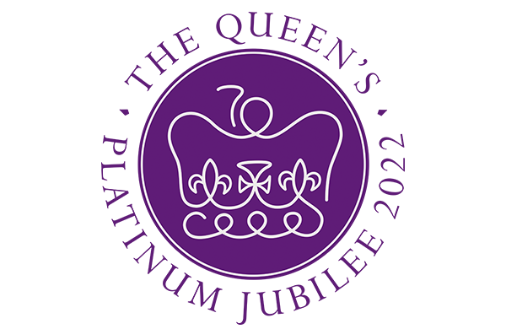

**What an Adventure!**

Next half term, we will be thinking about all the wonderful things we have done in Reception and preparing for our transition to Year 1.

But, what is an adventure?

In addition to our own experiences, will be learning about all kinds of journeys, maps, characters, settings and plots.

Maybe you could share some of your holiday adventures and places you are planning to visit in the summer?

*What kind of adventure would you take?*

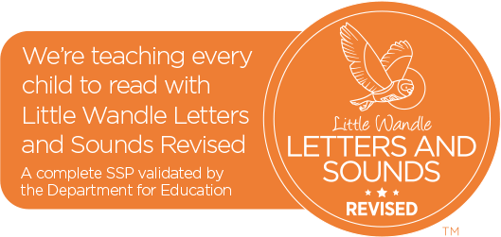

**Sports day**

Our EYFS sports day is on Wednesday 22nd June at 1:30pm.

Please see separate letter for details.

**Little Wandle**

From September, our school Phonics programme is changing to “Little Wandle: Letters and Sounds Revised”. We are hoping to run some workshops next year, focusing on the importance of reading and how we teach phonics. As ever, if you have any questions about phonics, the pronunciation of sounds or how we write certain letters - please do come and ask a member of staff. We will happily help and support your learning at home!

Our school Educater/Parent Passport subscription has ended. Please follow the class Twitter page for regular updates: @ElmridgeSchR

Homework

As mentioned, the children have been reading and writing longer words and sentences independently. They are working hard to use their phonics when spelling, but there are a few letters, which seem to be a common misconception when writing.

I have attached copies of the letters, which need a little further practise. Please encourage the children to start at the correct point and follow the shape accurately.

There is no need to return these sheets – they are for home learning support only ☺