Reception Newsletter

Sounds we have learnt this half term:

igh / oa / ar / or / ur / ow / oi / ear / air / er

Tricky words: was / you / they / all / are / my / her

If you need any further support with pronunciation of any sounds, please do let me know!

The children have really enjoyed reading Traditional Tales this half term! They have all been fantastic when re-telling the stories and repeated rhymes.

We have also looked at Nursery Rhymes and have enjoyed singing different songs. We recently made a link with a school in Australia, so we have been telling them about the songs and stories we know in the UK.

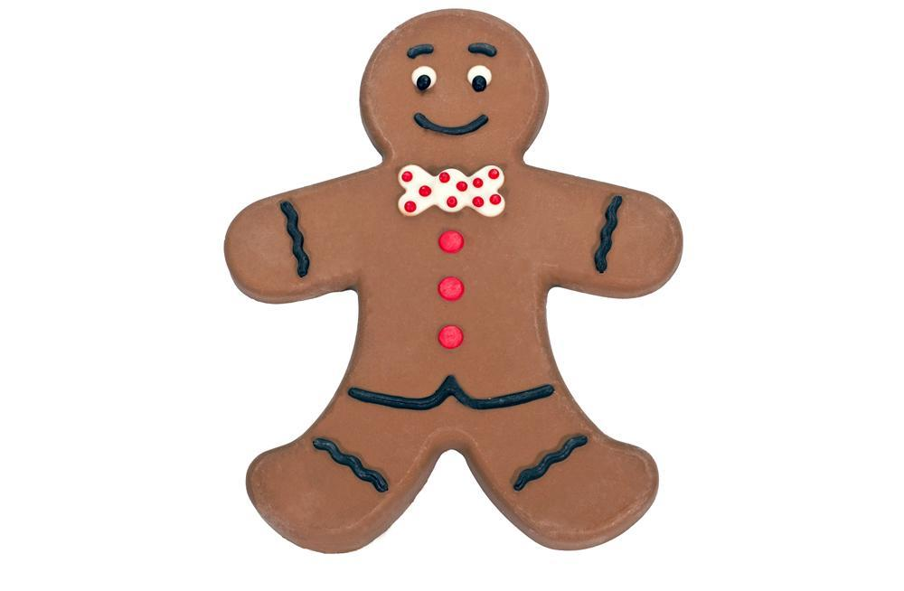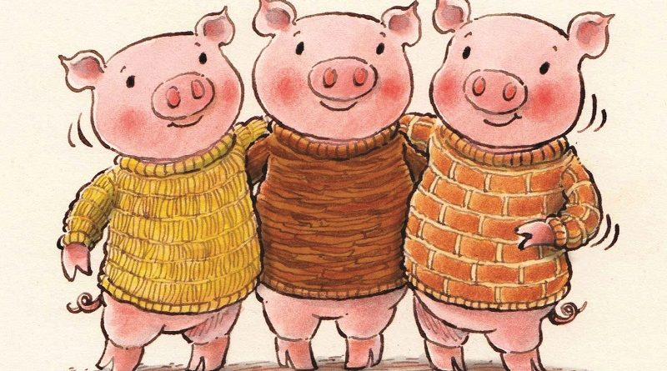

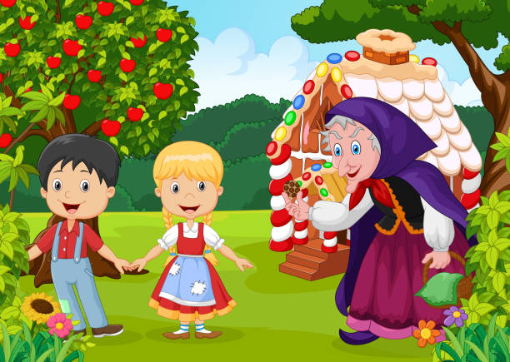



We have now learnt all the Phase 2 and Phase 3 sounds in our Phonics lessons! In addition, the children have been reading and writing ‘tricky words’. Remember: These are words that we can NOT sound out using phonics.

Phase 4 phonics teaches the children to blend and segment longer words, with adjacent consonants.

**Transition**

Over the Summer Term, we will be thinking about the children leaving EYFS and moving up into Year 1. Children settle better when transition between the classes is gradual. We will continue to ensure the children are independent in their self-help skills, and will begin to introduce some more formal learning experiences over the next term. Children will have the chance to visit the next classroom and meet with the teacher on a number of occasions.

**REMEMBER!** We now have an e-library where you can share our Guided Reading books at home!

**Traditional Tales**

Next half term, we will be learning about Kings, Queens and Castle! We hope to share some lovely celebrations to mark the Queen’s Platinum Jubilee – so finger’s crossed for some dry and sunny weather!

We will also be celebrating some important days and festivals – St George’s Day, Eid, Screen-Free week and walk to school week!

Please visit the school website/class page for more information.

PE days are THURSDAY and FRIDAY. Please check the school’s website to ensure children have the correct uniform for these sessions.

Homework

* In maths, we have been looking at numerical patterns. This includes evens/odds, double facts and counting in 2’s, 5’s, 10’s. Try using pairs of socks to create a practical maths activity.

How many socks are there? Is there an odd one out? Is this an odd number or an even number?

* People often celebrate Easter by eating chocolate, buns or cakes. Try making a sweet treat to share with your family ☺
* Please upload any photographs to Parent Passport! We would love to share your holiday news!

**Library Books**

We visit the library on TUESDAY mornings.

All library books and reading books must be returned on this day.