Reception Newsletter

Sounds we have learnt this half term:

j / v / w / x / y / z / zz / qu / ch / sh / th / ng / ai / ee / oo / oo

Tricky words: he / she / me / be / we

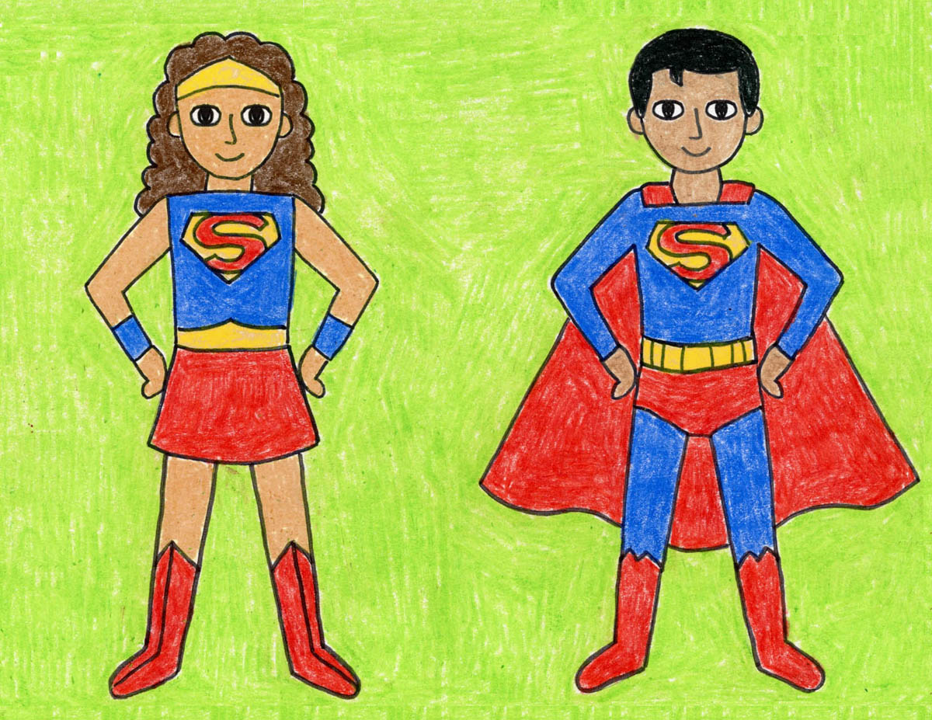

We have made a really good start with our Phase 3 sounds and tricky words. We are focusing on our letter formation and how to write a sentence independently. This includes capital letters, full stops and finger spaces…

*Ask your child if they can tell you a sentence about their half term. Can they write it down?

Wow! What a fantastic half term we have had!

The children have LOVED learning all about ‘real life superheroes’. We spoke about different occupations and how people help us in the community.

The highlight was our local walk into Hale Barns. We were able to meet (and thank!) so many people.

Well Done Reception!

**Traditional Tales**

Over the next half term, we will be talking about traditional tales - 3 Little Pigs, The Gingerbread Man, Little Red Riding etc.

We will be retelling stories, writing our own books and performing dance routines to match.

We will also be celebrating some important days and celebrations – Pancake Day, World Book Day, World Poetry Day, Mother’s Day and Easter.

Please visit the school website/class page for more information.

PE days are THURSDAY and FRIDAY. Please check the school’s website to ensure children have the correct uniform for these sessions, as well as ‘typical’ school days.

**International Project**

As part of our International School Award, we are planning to share work with an EYFS class in Australia! They teach using a “beach discovery” curriculum – which sounds very interesting and very different!

We will be sending them photographs of school and talking about our daily routines.

**REMEMBER!** Check Tiny Tracker for regular observations and updates!

Homework

* We have already sent home an activity pack with your child for the half term holiday – please let a member of staff know if you did not receive this.
* There are lots of ways you can make phonics fun at home! Children learn best through playing games. Use the flashcards to have a treasure hunt or look for sounds that match in books.
* Read anything and everything! Ask questions and encourage comprehension skills when reading bed time stories. Look for letters when out walking or hidden in a recipe book when you’re cooking!

**Library Books**

We visit the library on TUESDAY mornings.

All library books and reading books must be returned on this day.