Welcome to Reception 2021

Class Teacher: Mrs Stevenson
Teaching Assistant: Mrs Watson

Over the Summer holidays, please practise the following tasks:
- Try to independently put on your coat (even fastening buttons/zips if you can!).
- Try to get yourself dressed in the morning and at bed time. This will help with getting changed for PE lessons.
- In Reception, we use metal knives and forks. Have a go at using these on your own at meal times. Can you cut up soft food on your own?
- We should all be practising how to write our names. Even if you can make the letter shapes, look at the correct letter formations. Start and end in the correct place.

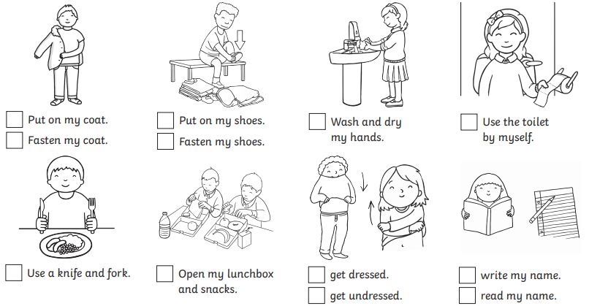

A few reminders

- Please bring named wellies to be kept in school. Children will wear these throughout the day and be asked to change into them independently.

- Please bring a named, waterproof coat – every day! We will always go outside, no matter what the weather.

- A drawstring bag is a handy to keep spare clothes or a PE kit on your peg. Backpacks are too large for the space we have. Please name all clothes, including spares.

- A book bag needs to be brought every day. Again, please avoid backpacks.

- Please bring a named water bottle into school every day. This must contain water only.

- Lunch boxes must be in line with our Healthy School Policy.

- Unfortunately, we no longer accept cakes/sweets for birthdays.

- Please ensure every item of clothing is clearly named.

@ElmridgeSch
@ElmridgeSchR

Please check our website and class page for more information

