I have tried to compile a list of useful websites to help you with ideas to keep your children entertained. Of course, as early years children their ‘work’ should be limited in favour of self-directed apply

Purple mash
Your child has already been given a login from school. When you login, you will see this screen. I will set some challenge ideas within the 2Dos tab at the top left. When these are done, I will be able to see and make comments too
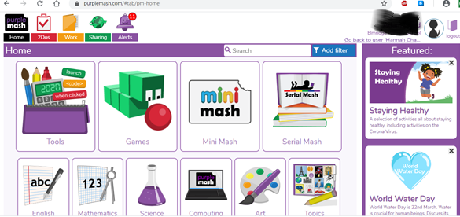

The other main feature of purple mash for our EYFS classes is the minimash section. For those who were in for the final two days, we have had a good play about and the children loved it. They are able to save most work in their virtual trays where I will also be able to see what they have created and make a comment.
There is also a blog on purple mash, which I will use to communicate with you anything relevant.

Oxford Owl reading.
This website contains lots of reading material for you and your child to enjoy for free. There are also lots of reading based activities including story sequencing pictures.
As long as you are logged into oxfordowl.co.uk (free account) you will be able to access lots of reading scheme books for free. Below is a link to take you directly to a selection of pink, red and yellow band books. Please remember comprehension and inference are crucial reading skills. Keep reading at a level that your child can enjoy
pink book band eBook
red book band eBook
yellow book band eBook

Handwriting practise
Please use the Read, Write Inc letter formation ditties to encourage correct letter formation (a download is within the Reception page of our website). For those who did one in school, ask the children to keep up their beanstalk diary with a simple sentence each week. I will attempt to upload ‘big write’ sheets with a picture. Children can write these with some, little or no support, based on their ability. Letter formation is a priority over volume of written work – a reception children

ICT
As well as through purple mash, some of you might like to create email addresses for the children and share those with each other. This will help with their sounding and blending and also offer keyboard experience. Obviously to be done under adult supervision!

Phonics play
This website is free for parents to create a login. They are familiar with it from school, we do the flashcards as well as games like buried treasure.

Amazon audible
Amazon’s children’s audible books will be available for a 30 day trial. This offers a lovely calming option for listening to a story without watching a screen!

Twinkl
Another website offering free access with a plethora of resources to download and work with in all areas of the EYFS. Just go to www.twinkl.co.uk/offer and enter the code UKTWINKLHELPS
Fitness
So many options! Joe Wicks is offering an online mass workout at 9am each day. You will be able to watch it at any time though.
In class we like to join in with Go Noodle videos that you can find online. Link to their favourite ones are here:
Milkshake
Banana, Banana, Meatball
Already listed on our website are some of the number songs that we watch and dance to.
During fair weather, as much outdoor time as possible (at a safe distance from others!) is the order of the day!

Play
So much development comes from play! Give them lots of time to create their own narrative in games. This is the area in which you will know them best so I won’t teach you to suck eggs!
If you can, play board games and encourage turn taking – they don’t always need to win either!

