Progression of Skills
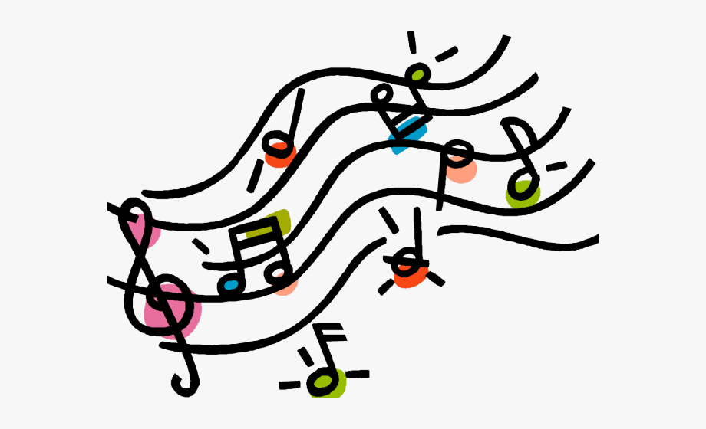

Music

ELMRIDGE PRIMARY SCHOOL
Music - Progression of Key Skills - Reception – Year 6

Controlling Sounds through singing and playing (Play and Perform)

Reception | Year 1 | Year 2 | End of KS expectations
Begin to build a repertoire of songs and dances. | - Use voices in different ways such as speaking, singing and chanting.  - To create and choose sounds  To perform simple rhythmical patterns, beginning to show an awareness of pulse.  - To think about others when performing. | - Use voices expressively and creatively. To sing with the sense of shape of the melody.  - To create and choose sounds for a specific effect.  To perform rhythmical patterns and accompaniments, keeping a steady pulse.  - To think about others while performing | - Use voices expressively.  - Play tuned and un-tuned instruments.  - Rehearse and perform with others

Year 3 | Year 4 | Year 5 | Year 6 | End of KS expectations
- To sing in unison, becoming aware of pitch.  - To perform simple rhythmic and musical parts, beginning to vary the pitch with a small range of notes.  - To think about others while performing. | - To sing in unison maintaining the correct pitch and using increasing expression.  - To play and perform parts with an increasing number of notes, beginning to show musical expression by changing dynamics.  - To think about others while performing. | - To sing in unison with clear diction, controlled pitch and sense of phrase.  - To play and perform parts in a range of solo and ensemble contexts with increasing accuracy and expression.  - To maintain my own part and be aware how the different parts fit together. | - To sing in solo, unison and in parts with clear diction, controlled pitch and with sense of phrase.  - To play and perform with accuracy, fluency,  control and expression.  - To think about the audience when performing and how to create a specific effect. | - Sing songs in unison and two parts.  - To play tuned and un-tuned instruments with control and accuracy.  - To practise, rehearse and present performances with an awareness of the audience

Creating and developing musical ideas (create and compose)

Reception | Year 1 | Year 2 | End of KS expectations
Children sing songs, make music and dance, and experiment with ways of changing them. | - To know about and experiment with sounds  - To recognise and explore how sounds can be organised, to identify and organise sounds using simple criteria e.g. loud, soft, high low. | - Repeat short rhythmic and melodic  patterns  - To Begin to explore and choose and order sounds using the inter-related dimensions of music*. | - Create musical patterns  - Explore, choose and  organise sounds and musical ideas

Year 3 | Year 4 | Year 5 | Year 6 | End of KS expectations
- To create simple rhythmical patterns that use a small range of notes.  - To begin to join simple layers of sound, e.g. a background rhythm and a solo melody. | - To create rhythmical and simple melodic patterns using an increased number of notes.  - To join layers of sound, thinking about musical dynamics of each layer and understanding the effect. | To create increasingly complicated rhythmic and melodic phrases within given structures. | To create and improvise melodic and rhythmic phrases as part of a group performance and compose by developing ideas within a range of given musical structures. | - Improvise,  developing rhythmic and melodic material when performing  - Explore, choose,  combine and organise musical ideas with musical structures

Responding and reviewing appraising skills
Reception | Year 1 | Year 2 | End of KS expectations
Children represent their own ideas, thoughts and feelings through design and technology, art, music, dance, role play and stories. | - To talk about how music makes you feel or want to move. E.g. it makes me want jump/shout/sleep etc.  - To think about and make simple suggestions about what could make their own work better. E.g.: play faster or louder. | - To respond to different moods in music and explain thinking about changes in sound.  - To identify what improvements could be made to own work and make these changes, including altering use of voice, playing of and choice of instruments. | - Explore and express  ideas and feelings about music using movement, dance and expressive and musical language.  - To make  improvements to my own work

Year 3 | Year 4 | Year 5 | Year 6 | End of KS expectations
- To explore and comment on the ways sounds can be used expressively.  - To comment on the effectiveness of own work, identifying and making improvements. | - To recognise and explore the ways sounds can be combined and used expressively and comment on this effect.  - To comment on the effectiveness of won work, identifying and making improvements based on its intended outcome. | - To describe, compare and evaluate different types of music beginning to use musical words.  - To comment on the success of own and others work, suggesting improvements based on intended outcomes. | - To describe, compare and evaluate different types of music using a range of musical vocabulary including the inter-related dimensions of music*.  - To evaluate the success of own and others work, suggesting specific improvements based on intended outcomes and comment on how this could be achieved. | - Analyse and  compare sounds. Explore and explain ideas and feelings about music using movement, dance and expressive and musical language.  - To reflect on and  improve own and others work in relation to its intended effect.

Listening and applying knowledge and understanding

Reception | Year 1 | Year 2 | End of KS expectations
Children develop preferences for forms of expression.  They use movement to express feelings and create movement in response to music. | - To begin to identify simple repeated patterns and follow basic musical instructions.  - To begin to understand that musical elements can be used to create different moods and effects.  - To begin to represent sounds with simple sounds including shapes and marks.  - To listen to short, simple pieces of music and talk about when and why they may hear it. E.g: a lullaby or Wedding march. | - To identify and recognise repeated patterns and follow a wider range of musical instructions  - To understand how musical elements, create different moods and effects.  - To confidently represent sounds with a range of symbols, shapes or marks.  - To listen to pieces of music and discuss where and when they may be heard explaining why using simple musical vocabulary. E.g. It’s quiet and smooth so it would be good for a lullaby. | - To listen with  concentration and recall sounds within increasing aural memory.  - To know how the  combined musical elements of pitch, duration, dynamics, tempo, timbre, texture and silence can be organised and used expressively within simple structures.  - To understand that  sounds can be made in different ways and described using given and invented signs and symbols.  - To know how music  is used for particular purposes

Year 3 | Year 4 | Year 5 | Year 6 | End of KS expectations
- To listen with attention and begin to recall sounds.  - To begin to understand how different musical elements are combined and used to create an effect.  - To begin to recognise simple notations to represent music, including pitch and volume.  - To listen to and begin to respond to music drawn from different traditions and great composers and musicians. | - To listen to and recall patterns of sounds with increasing accuracy.  - To understand how different musical elements are combined and used expressively.  - To understand and begin to use established and invented musical notations to represent music.  - To listen to, understand a wide range of high quality live and recorded music drawn from different traditions, great composers and musicians. | - To listen to and recall a range of sounds and patterns of sounds confidently.  - To begin to identify the relationship between sounds and how music can reflect different meanings.  - To recognise and use a range of musical notations including staff notation.  - To listen to a range of high quality, live and recorded music from different traditions, composers and musicians and begin to discuss their differences and how music may have changed over time. | - To listen to, internalise and recall sounds and patterns of sounds with accuracy and confidence.  - To identify and explore the relationship between sounds and how music can reflect different meanings.  - To use and apply a range of musical notations including staff notation, to plan, revise and refine musical material.  - To develop an understanding of the history of music from different, cultures, traditions, composers and musicians evaluating how venue, occasion and purpose effects the way that music is created and performed. | - To listen with  attention to detail and to internalise and recall sounds.  - To know how the  combined musical elements of pitch, duration, dynamics, tempo, timbre, texture and silence can be organised within musical structures and used to communicate different moods and effects.  - To know that music is  produced in different ways and described through relevant established and invented notations.  - To understand how  time and place can influence the way music is created.
*Inter-related dimensions of music (dynamics):

PULSE: the steady beat of a piece of a piece of music
PITCH: the melody and the way the notes change from low to high and vice versa.
RHYTHM: or duration is the pattern of long and short sounds in a piece of music
DYNAMICS: Loud and soft
TEMPO: Fast and slow
TIMBRE: The type of sound – whisper/hum/sing/talk (examples with the voice) or twinkly/hard/soft (examples with instruments)
TEXTURE: Layers of sound (number of instruments or voices playing together)
STRUCTURE: The way the music is laid out –e.g. Verse, chorus, verse.

