

SCHOOL COUNCIL
POLICY

CONTENTS

Mission Statement 3

Make up of the Council 3

Election Procedure:

Frequency 3
Before the Election 3
The Election 4

Training for Representatives 4

Key Roles: The Council Executive 4
The Class Representatives 5
The Link Teacher 5
All Children in the School 5
Class Teachers 6

School Council Meeting:

The Agenda 7
Discussions and Decision-making 7
Expected Behaviour of Class Reps 7
Boundaries of Decision-Making 8

Class Council Meetings 9

Communication 9

Sub-committees 10

Success Criteria of the Policy/Constitution 10

Reviewing the Policy/Constitution 10

Appendices 1-7

Mission Statement

The aims of the school council are to:

- Develop the concepts of citizenship, democracy, fairness, rights and responsibilities of all children in the school.
- Give children the opportunity to work considerately, fairly and cooperatively using democratic procedures to make and implement decisions in areas which affect their lives in school.
- To promote pupil voice whereby all children have a means to express their views on issues in school which affect them.
- Give children an opportunity to have an input on school policy.

Make up of the Council

There will also be a member of staff who will act as Link Teacher. All children from Y1-6 will need to be taught about the School Council in order to understand the purpose of it and how it will operate. Teachers will discuss the form and function of the School Council, as they deem appropriate to their level, before the elections.

Election Procedure
Frequency

Each year elections will be held in Summer 2 for the forthcoming Academic Year. The election term will be a year.

Before the Election

- Outline the role of the Class Representatives (see section in policy).
- Invite children to discuss the qualities which a good class representative will have. It may help to scribe these onto paper so that the children can read them again before they come to elect their Class Representative.
- Outline the expected behaviour of a Class Representative (see section in policy).
- A child can apply in their class to be the representative providing they have not held office twice before, using an application form (for KS1 and KS2 – see Appendix).
- Give children a few days to apply for the post in their class (see next section on ‘The Election’).
- Set aside time in class to share the application forms anonymously.
- Teachers conduct an election in their class, with each class member choosing two candidates.

The Election

Elections will take place in Summer 2 to allow a smooth transition.

- One boy and one girl (where appropriate) will be elected from each class in Years 2-6.
- There will then be a secret ballot, all children voting for one boy and one girl who they think would make the best representative.
- Candidates can vote for themselves.
- Children can only hold office for a maximum of 2 years during their school career.
- The class teacher and NOT a child will count the votes.
- In the event of a tie between candidates the Class Teacher will go to the class to carry out a further secret ballot and count the votes as before.
- The Class teacher will announce the names of the boy and girl who received most votes. They will then be the Class Representatives for that class for the appropriate term of office as outlined above.
- If a School Councillor leaves part way through the year, the Link Teacher will oversee a new election process where children complete stages 5-7 from “before the election” and hold a secret ballot within class sometime afterwards.

N.B. Secret Ballot, Secret Count. The number of votes each candidate receives, who came second or third should NOT be announced. This will help prevent people being worried about standing for election in case no one votes for them.

Training for Representatives

Electing the new School Councillors during Summer 2 will allow the outgoing Council members opportunity and time to train the incoming Council members. The Link Teacher will organise any additional training as necessary to help equip the members of the school council with the skills to carry out their roles. It will be the job of existing Councillors, with the support of the Link Teacher if necessary, to train new council members as they are elected during the year.

Key Roles

The Council Executive
Following the training day, the council will elect by secret ballot a Council Executive for the year. The Executive will consist of:

The Chair – The Chair will structure all council discussions, ensure that all members of the council who wish to speak have an opportunity to do so, call for proposals of action at the end of discussions and get decisions regarding these by votes. They will ensure that the Secretary properly minutes decisions and important opinions. They will oversee any Sub-Committees that are formed by the Council.

The Vice-Chair – The Vice-Chair will support the Chair in his/her role; perhaps chair parts of meetings if requested to by the Chair and stand in for the Chair if they are unable to attend a meeting.

The Secretary – The Secretary will minute the School Council meetings, noting down any decisions made, jobs that need to be done and any other important opinions or business (see Appendix for explanation of minutes).

The Treasurer – The Treasurer will look after the School Councils Budget. They will be responsible for reporting on what has been spent, what it has been spent on and how much is left.

The Class Representative

The Class Representative will:

- Bring the opinions and ideas of their class regarding Council business to the Council meetings.
- Bring their class’s ideas for the agendas of Council meetings and issues, which their class feel need to be discussed at the Council meetings.
- Report the minutes from Council meetings back to their classes.
- Lead class based discussions
- Keep the class file organised
- Help to organise sub-committees when necessary.
- Keep to the expected behaviour of Council Members (see below).

The Link Teacher
The Link Teacher’s role is to facilitate the Council’s smooth running. The Link Teacher will take care not to dominate the Council, the running of which is the responsibility of the Council Members.

The Link Teacher will:

- Organise the Class Representative Elections.
- Organise the training of the Council Members
- Act as a link between the School Council, the Leadership Team and School Governors
- Be available for consultation on the writing of agendas and minutes
- Be at meetings to give advice and information on request.
- Help oversee any sub-committees though this is primarily the role of the Chair.

Should the Link Teacher feel they are unable to fulfil their role, they may resign their position.

All Children in the School

All children in the school will:

- Elect the boy and girl in their classes whom they feel will make the best class representatives.
- Express their opinions and ideas about Council decisions and issues they would like the Council to discuss through Circle Time and Class Council meetings.
- Listen to the feedback from Council meetings given by their Class Representative.
- Accept the responsibilities, which go with any rights the School Council may organise for children in the school.
- Participate in sub-committees, which the School Council may organise.

Class Teachers

Class teachers will:

- Organise the election of the Class Representatives for their class.
- Allow Class Representatives to attend School Council meetings.
- Allow time for Class representatives to feedback about Council meetings in the week after the meeting was held.
- Allow time for the discussion of Council business before the next School Council meeting. This may occur in Circle Time, Class Council time or whenever the class teacher feels it is appropriate.
- Chair such discussions, or organise a child to be trained to chair such discussions in the class (see Appendix for ‘Leading Discussions’ sheet).
- Help children in their class to understand the key concepts of citizenship, fairness, democracy, co-operation, rights and responsibilities in order that they feel involved with School Council business and recognise the benefits they are enjoying as a result of the School Council.

School Council Meetings
The School Council will meet at least once in full every half term. The date and time of the next meeting will be announced at each School Council meeting.

The Agenda
At each meeting the School Council will set an agenda for the next meeting (see Appendix for agenda sheet). This agenda will reflect issues raised in class meeting and include:

- Feedback from class meetings about the previous School Council meetings.
- Feedback from any sub-committees in operation and from meetings with relevant staff or pupils.
- Discussions and decisions around issues agreed in setting the agenda at the previous meeting.
- Organise any jobs that need doing as a result of these decisions.
- Setting the next meeting’s agenda.
- Any other business.

Discussions and Decision-making
Typical areas of discussions and decision-making may be fundraising, behaviour, the playground, the curriculum or special events.

The Chair tells the meeting clearly what the issue is that the meeting is about to discuss.

The Chair asks for people’s ideas/opinions about this particular issue, checking that all who might have something to contribute have a chance to speak.

The Chair asks someone to make a clear proposal of action and someone to second it.

A decision is made by a majority vote.

Any jobs that need doing as a result of that decision are organised and allocated.

Decisions and important opinions are noted down by the Secretary in the minutes (see Appendix for minutes sheet). These act as a record of decisions and they are kept in a central file and are also put into the School Council file in every classroom. The Class Representatives use these minutes to feedback to their classes, Nursery and Reception teachers may use them to feedback, if they feel the issues are relevant to their children.

It is important that all decisions made by the School Council are within the boundaries of their decision making power (see below).

Expected Behaviour of Class Representatives

It is expected that in a meeting a Class Representative will keep to the following rules:

- Attend all meetings when they are in school.
- Respect what other people are saying.
- No put-downs.
- Follow the meeting rules.
- Accept majority decisions made by the School Council and work to implement them.
- Accept any veto of School Council decisions made by the Senior Leadership Team.

If a Class Representative is not able to fulfil his or her role and keep to the above rules, they will be given support to do so for a trial period by the School Council Executive, the Link Teacher and by that Representative’s class teacher. If the Representative still cannot fulfil their role a new representative may have to be elected by that class.

Boundaries of Decision Making: Rights and Responsibilities

The aim is that the School Council is an ‘active’ council rather than a ‘petitioning’ council. This means that the School Council is working to implement its decisions rather than making lists of demands upon staff in the school.

If the School Council asks for a right for the children in the school to do something, the School Council must ensure that the children meet the responsibilities which go with the right.

For example, the children may ask for the right to eat their packed lunches outside in the quite area. In this case some responsibilities may be needed to ensure that the area remains clean and tidy and that no problems are caused for the lunchtime staff. The School Council must come up with proposals, which convince all staff and children that they can meet those responsibilities and communicate those responsibilities to all children. If the responsibilities cannot be met, the right will be withdrawn. It is up to the School Council to resolve any problems the children have in exercising their rights.

The School Council will be given a small budget that they must take responsibility for. If a decision made by the School Council requires additional funding, the School Council must raise the funds itself.

School Council decisions must not place an unfair burden on any member of the school community. For example, it cannot demand that a teacher run a particular after school club (though it could confirm to teachers that children want a particular club and come up with proposals to help a club be created).

School Council decisions must conform to School policy, Local Education Authority policy, Government policy and the National Curriculum and must not adversely affect the health and safety of any member of the school community.

The Leadership Team can veto any School Council decision that does not meet the above criteria and withdrawn any right earned by the children if the responsibilities, which go with it, are not being met. They must explain any such decisions to the School Council.

Class Council Meetings

You may use Circle Time or find other times to discuss School Council business in your class.

Class Council meetings need to reflect on the feedback from the previous School Council meeting. The Class Representatives need to be given a chance to feedback to the class, preferably on the same day as a School Council meeting. Discussions can happen at a later time.

There may not need to be a Class Council meeting about every School Council meeting. They need only take place if the Class Representatives and/or the other children in the class feel they need one, or if you feel there needs to be one.

You may wish to lead any discussions yourself, or train the children to run the meetings. (See Appendix for sheets, which help the children to run a discussion.)

At the end of the meeting, check that the Class Representatives are clear about what they are going to feed back to the School Council.

For the first meeting, before the School Council sits, the aim will be to come up with two ideas which the School Council can discuss for possible inclusion in future agendas for School Council meetings. You could do this by noting some ideas. It may be useful to suggest some categories, which the children could think about. Some examples might be:

- The playground
- Behaviour
- Homework
- Lunchtimes
- The Curriculum
- Special events

Once you have finished, get the children to choose two for the Class Representatives to take to the School Council. You could do this by following the proposals, seconding and voting process. After this you could keep the ideas you brainstormed for future use.

Communication

The School Council can communicate with the other children in the school by:

- The Class Representatives feeding back from the School Council meetings and feeding back from class meetings to the School Council.
- The minutes of the meetings being place in the School Council files in the classroom.
- Announcements in assemblies.
- School Council Surgeries

Other means may be:

- A School Council newsletter.
- Suggestion boxes.
- A School Council notice board.

The Link Teacher will enable the School Council to communicate with the staff of the school.

Sub-Committees

The School Council may wish to set up a sub-committee to work in a particular area, e.g. to organise a fund-raising event, gather information around a particular issue or make up a newsletter.

Members of a sub-committee will be members of the School Council, plus any other pupils, as necessary.

Setting up a sub-committee

- The School Council agrees to set up a sub-committee.
- The School Council identifies an elected Councillor to act as co-ordinator
- The co-ordinator invites other interested Councillors to meet.
- Decisions follow normal council procedures.
- Issues raised at the meetings are brought to the School Council for consultation.
- Support for the sub-committees by a teacher may be available on request.

Success Criteria of the Policy/Constitution

The policy/constitution will be successful if:

- The School Council is meeting regularly.
- It is operating independently.
- It is making and implementing decisions successfully within the outlined boundaries.
- The whole school community feels involved in the process and all members feel it is beneficial to them.

Reviewing this Policy/Constitution

The School Council and staff of the school will review this policy at the beginning of every school year.

Approved by the Head of School
To be Reviewed: September 2018

APPENDIX 1
KS2 School Council Application
Name:
Class:
Reasons I would be a good representative:

Things I would like to change/improve/ideas

Qualities I have that would make me a good representative

APPENDIX 2
KS1 School Council Application

My name is……………………………………………
My class is…………………………………………….

I would like to be a school councillor because:
(Write a few words)

I would describe myself as:
(write a few words)

If I had a magic wand this is how I would improve the school:
(draw a picture or write a few words)

APPENDIX 3
STRUCTURING A DISCUSSION


- Tell the meeting clearly what
the issue is that you are
going to talk about.

- Ask for people’s ideas/opinions
about this particular idea.


- Get someone to make a clear
proposal and someone to

second it.

- Get a decision by vote.

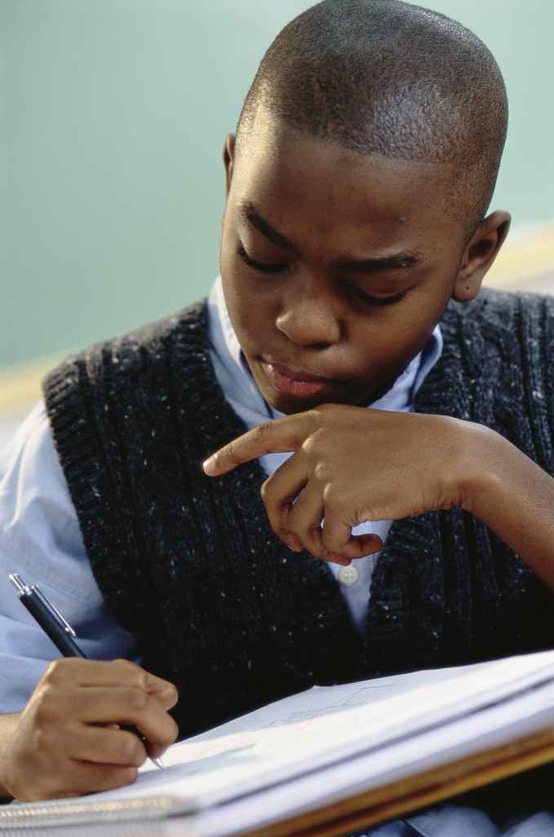

- Check the secretary has written
it down in the minutes.

APPENDIX 4

SCHOOL COUNCIL MEETING AGENDA

Date: Time:

Venue:

Chairperson: Secretary:

Agenda

- Apologies for absence

- Minutes of last meeting

- Business to be discussed at this meeting

- Any other business

- Date for next meeting:

APPENDIX 5

MINUTES OF SCHOOL COUNCIL MEETING

Date: Time:

Venue:

Present:

Apologies:

Date of next meeting:

Venue:

Time:

APPENDIX 6

MINUTES

WHAT ARE THEY? They are a record of what was discussed last time.

HOW ARE THEY MADE? The secretary makes notes during the meeting, of all
the decisions that are made and important issues that
are discussed. These notes can be photocopied and
given to each member of the Council.

WHO ARE THEY FOR? Everyone!

WHEN DO THEY GET THEM? Each class will have them read to them by their Class
Representative during reporting back time and then
Have them put on their class notice board.

WHERE ARE THEY KEPT? The Secretary keeps all the minutes in a book or file
Called the “Minute Book”.

WHY DO WE NEED THEM? The Chairperson needs them when planning or leading
the next meeting.

Each Council member needs them to check whether

There is anything they promised to do at the last
meeting that needs to be done.

Anyone should be able to check at any time on
decisions that were made in the past.

The Governors might need to see them so that they are
kept informed of the Council’s activities.

The Headteacher might need to refer to them when
Talking to other teachers or members of staff about
School Council issues.

SO REMEMBER – THE MINUTES ARE VERY IMPORTANT

APPENDIX 7
RUNNING A DISCUSSION


If you are the CHAIRPERSON you will lead the discussions at
School meetings and you decide who speaks when.

People should raise their hands and wait for you to ask them
to speak.

A meeting will contain a number of discussions depending on how
many items are on the agenda.

During each discussion keep these questions in your mind: Excuse me
could one person
speak at a time
Has everyone had a change to speak who wants to, including the please
quieter people? (if you’re not sure you can ask them).

Are lots of people talking at once? (If so you should politely
Interrupt them.)

Are people going off the subject? (If so, you can say, “Excuse me,
but that is not what we are talking about at the moment.”)

Is there anyone at the meeting who you think might know more about the subject being discussed. (If so, you can invite them to speak eg your Link Teacher.)


After some discussion you will have to try to reach a
decision. Again ask yourself:

I propose that Is more research or information needed before a sensible
decision can be made?

If so, you could ask for volunteers to form a sub-committee to

find out more by the next time you meet.

Do you think a decision could be made now? If so, ask
someone to make a clear proposal, eg someone might say,
“I propose we ask if we can organise a chess championship.”

Do most people agree with this proposal? You can find out
by asking people to raise their hands if they do. If less than
half the people put their hands up, the issue needs more
discussion.

Now you will have to repeat the process with next item to be discussed.

Remember, you must always be fair and firm in your role as discussion leader.
APPENDIX 8
VOTING FORMS

VOTING FORM FOR THE SCHOOL COUNCIL

Name:

Form:

Place an ‘x’ by the candidate of your choice

VOTING FORM FOR THE SCHOOL COUNCIL

Name:

Form:

Place an ‘x’ by the candidate of your choice

- Fill in the names of your class candidates on the appropriate form.
- Photocopy enough forms for each child in your class.
- Children vote for one candidate and place the forms in the ballot box.

