School Council Meeting Agenda
1st February
3.30pm
- Apologies - is everyone here?- Madeleine, Charlie and Miya are not coming, Harry and Isa are not coming.

- Miss Price update from last meeting- Cooking club passed on to Mrs Durrant
Mr Edmundson is keen to have a technology day. This will happen after the SATs and will be organised by Mrs Armstrong, Mrs Bridge, Mr Broomhead and Miss Mills
Bring a toy to school day- Mr Edmundson said that teachers can decide if they would like a toy at the end of term
Playground-KS2 will have equipment out during first break on Friday’s, starting this week
- Surgery news
Maths club-is already starting, next term
Bigger cloakroom KS2-we don’t have the space in the school but some extra pegs have been added
Teddy Day- bring your teddy bear on pajama day-we might do this
Swimming pool-Charlie said no to this suggestion
School pet- Miss Price will speak to Mr Edmundson about this. Ebrahim said some people might be alergic
Pajama day-we might be using this
Playground equipment-swing and slide –Miss Price explained that the equipment is being sorted but it takes a long time
Sweet day/happy meals-we are a healthy school so can’t have a sweet day
Easter Egg hunt-Ebrahim had this suggestion last time as said it was for KS1
Ebrahim made a point that we need to tell everyone that the surgery is a chance to give a suggestion. It will not necessarily happen.

- World Book Day competition- Display will go up on early bird reading. Classes have been asked to do something and parents have been tweeted what they like about early bird reading.

- Question of the month containers- Decided what we want and Miss Price will look for them. Question of the month stays the same.
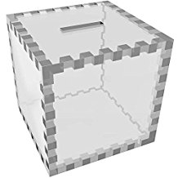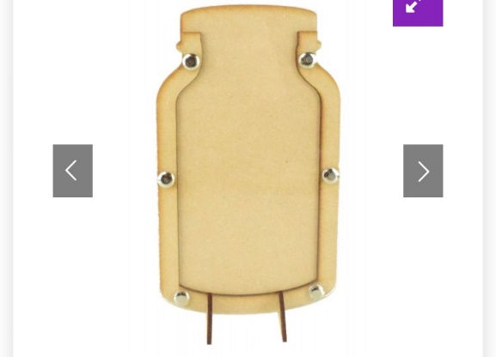

- Any other business- Darcy asks if the Safeguarding Ambassadors will work with the councillors. Rap battle- each class make up a rap about their classes. Paper and cardboard bins need to be seperarted- Will take it on. Chairpeople will make sure each class has a paper and cardboard bin. Tuck shop for ks2.

